
Atlanta Walks
For Our Children and Siblings Gone Too Soon

The Compassionate Friends National Walk to Remember will be held at 8 a.m. Sunday morning, Aug. 9, in Portland, Oregon, the National Conference host city, prior to the closing ceremony.

First held in conjunction with the national conference in 2000, this Remembrance Walk has quickly become a highlight for conference-goers with more than 1,000 people joining together hand-in-hand, arm-in-arm to cover the two-mile course arranged for the event.

This is our way to honor the memories of children and siblings who we will never forget.

Families who have had a child die, but are unable to attend the conference or walk, are invited to include their child’s name on our “Atlanta Walks” banner carried by members of our local Atlanta TCF Chapter attending the Portland conference.

If you would like to have your child, sibling or grandchild’s name included, please complete the following form and return it to us as soon as possible. The deadline is July 15.

Atlanta Walks – 2009 in Memory of our Children and Siblings

Yes, I would like to have my child/sibling/grandchild included on the Atlanta Walks banner.

Child’s Name___________________________________________________________
(Please print clearly)

Yes, I would like to help with the Walk to Remember expenses and support the work of The Compassionate Friends Atlanta Chapter by making a donation in the amount of:
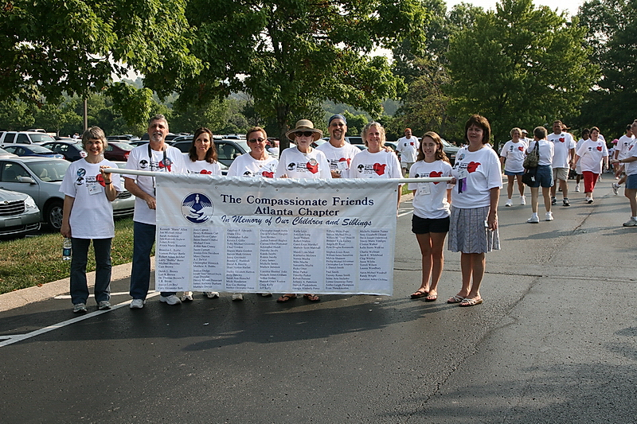
$___________ ($10, $25, $50…….)

Please mail your check payable to “The Compassionate Friends” to:

The Compassionate Friends
c/o Jayne Newton
808 Brentway Court
Lilburn, GA 30047

Thank you for your support. (Deadline July 15)

Sample Banner from 2008 Walk at the Nashville Conference
“Atlanta Walks…
In Memory of Our Children and Siblings”

