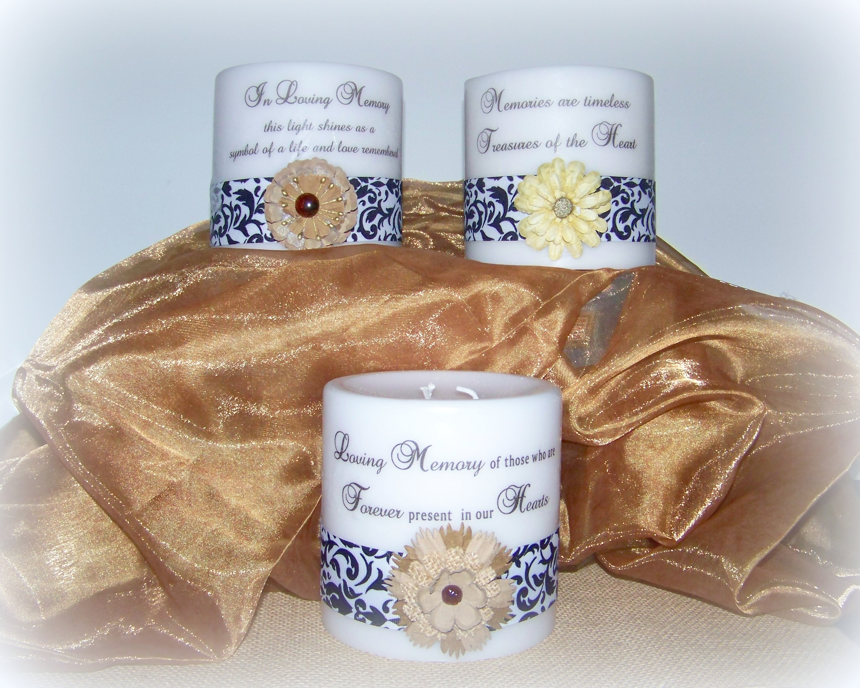  This year’s centerpiece will be a beautiful candle featuring one of three messages with or without embellishments. Choose from one of the 3 wordings below.  - Loving Memory of those who are Forever Present in our Hearts  - Memories are timeless treasures of the Heart  - In Loving Memory this light shines as a symbol of a life and love remembered | Atlanta Chapter  37th Annual Candlelight Remembrance Service  Saturday, December 2, 2017  Centerpieces and Poinsettias  Sponsor a Centerpiece or Poinsettia  “In Memory of Your Child/Sibling/Grandchild”  We will display a sign “In Memory of Your Child/Sibling/Grandchild” next to each sponsored item.  Each candle will be unique but this gives you an idea of the style. The embellishments may be different.  If you don't want a flower embellishment on your candle, I can leave it off. Just let me know.  Deadline to order candle - November 25th.  Measuring 5" tall by 5" wide  www.tcfatlanta.org/Candlelighting2017.html  www.tcfatlanta.org/Candlelighting2017Candles.html
After the reception, you can take the candle or poinsettia home with you as a special remembrance. If you cannot attend the candlelight service, your poinsettia will be donated to a newly-bereaved family to take home after the reception. We can mail the candle to you for an additional amount of $10.00. The cost of a Candle or Poinsettia is $30. Please consider adding an additional contribution to this fee, to help cover speaker and other Candlelight Service costs. The net proceeds from this fundraiser will help support our annual candlelight remembrance service.

Your Name __________________________________________________________________________________________________

Child's or Sibling's name: Card will read “In Memory of ______________________________________________________________”

Child or Sibling’s: Birth Date: ________________________________ Angel Date: ______________________________

I want to sponsor a Poinsettia: _____ $30 (Poinsettia)

I want to sponsor a Remembrance Candle with the following wording: ______________ $30 (Candle)

_____________ Loving Memory of those who are Forever Present in our Hearts

_____________ Memories are timeless treasures of the Heart

_____________ In Loving Memory this light shines as a symbol of a life and love remembered

_____________ I do NOT want a flower embellishment on my candle...only the words and ribbon.
If you want to include a picture of your child to be displayed with the Candle and Memory Card, please do. The picture will be returned after the service. ) We will also include your child's picture in the Memory Video.

Please make your check payable to: “The Compassionate Friends” and mail, along with completed form, to:
The Compassionate Friends, c/o Jayne Newton, 808 Brentway Court, Lilburn, GA 30047
To order online and pay by paypal www.tcfatlanta.org/centerpiecedonationdataform.html

