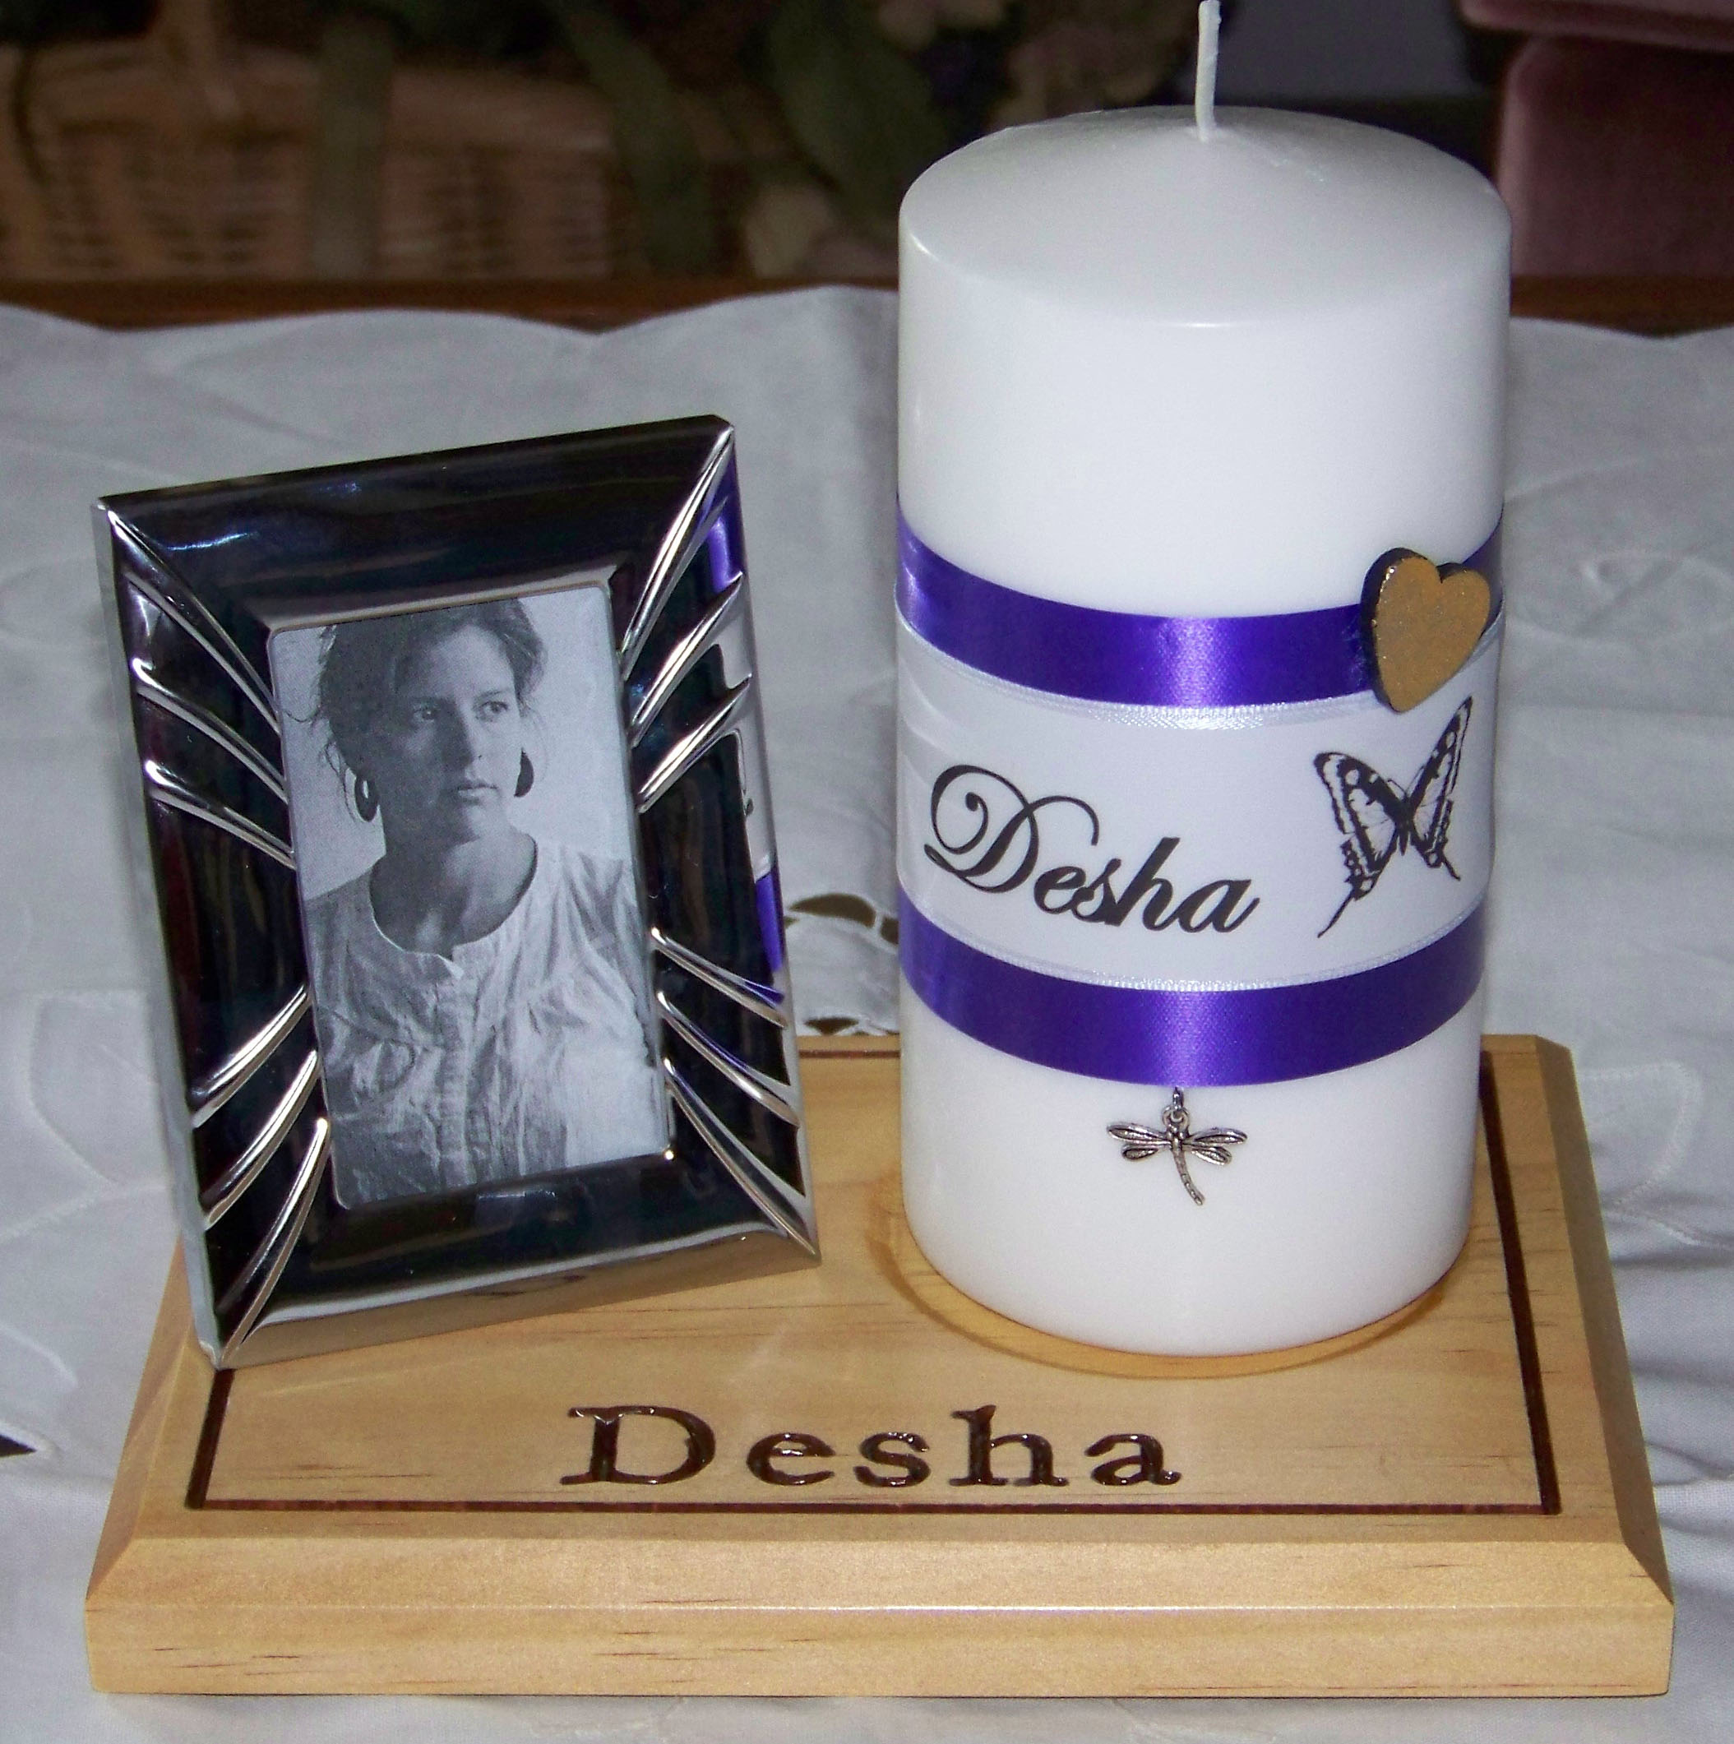  Perfect for lighting to let your loved one's light and memory shine! This is our original keepsake remembrance candle.  This order comes with:  1) 1 Personalized White Pillar Candle (unscented) decorated with white and purple ribbon and your loved one's name printed on a clear label which is pressed over the ribbon  2) 1 Keepsake charm (choose dragonfly or angel wings) and a little silver-painted wooden heart (located at the side of the candle by the name)  3) 1 Carved and personalized pine stand with your loved one's name carved and painted in dark brown  4) 1 Photo frame (silver color) | Atlanta (Tucker) Chapter  34th Annual Candlelight Remembrance Service  Saturday, December 6, 2014  Remembrance Candles and Poinsettias for Sale  Deadline to Order in November 15th  If we have a picture of your child,  we will display your child’s photo next to each sponsored item.  After the reception, you can take your candle or flowers home with you as a special remembrance. If you cannot attend the candlelight service, your poinsettia will be donated to a newly-bereaved family to take home after the reception. Special ordered Remembrance Candles can be mailed directly to you for an additional shipping fee of $12.50.  The cost of a Remembrance Candle or Poinsettia is $30. Add $12.50 if you need the candle shipped directly to you. Please consider adding an additional contribution to this fee, to help cover speaker and other Candlelight Service costs. The net proceeds from this fundraiser will help support our annual candlelight remembrance service.
Your Child’s Name (Name as you would like it to read on the Candle and Wooden Stand)

____________________________________________________________________________________________________

And for Poinsettias…Card will read: Sponsored “In Memory of ________________________________________________________”

I want to sponsor a: _____Candle with Angel Wings _______ Candle with Dragonfly _____ Poinsettia

Please check: _____ $30 (Candle/Poinsettia) Add ____ $12.50 ( to ship candle directly to you)
$_____ Additional contribution to go toward the candlelight service

Please make your check payable to: “The Compassionate Friends” and mail, along with completed form, to:
The Compassionate Friends, c/o Jayne Newton, 808 Brentway Court, Lilburn, GA 30047

To order online and pay by paypal www.tcfatlanta.org/centerpiecedonationdataform.html

Please include an original photo of your child or email the photo in high resolution to Jayne@tcfatlanta.org

